Batch: 04
Roll No.: 16010123012

Experiment / Assignment / Tutorial No.: 04

TITLE: Title: Working with Geospatial data

Objective:
To analyze and interpret the visualization the geospatial Data
_________________________________________________________________________
Expected OUTCOME of Experiment: CO 1
Learn how to locate and download datasets, extract insights from that data and present their findings in a variety of different formats _____________________________________________________________________
Books/ Journals/ Websites referred:
- Data Analysis with Microsoft Excel, Wayne L. Winston, Microsoft Press.
- Excel 2019 Bible, John Walkenbach, Wiley.
- Practical Statistics for Data Scientists, Peter Bruce and Andrew Bruce, O’Reilly Media
_____________________________________________________________________
Background Theory:
Tableau provides comprehensive support for working with geospatial data, allowing users to visualize, analyze, and interpret spatial patterns in an intuitive and interactive manner. It accommodates various geographic data types, including latitude–longitude coordinates, administrative regions such as countries, states, cities, and postal codes, as well as custom spatial datasets like shapefiles and GeoJSON files. These features enable practical real-world applications such as visualizing water quality parameters across river networks, identifying pollution-prone zones along coastlines, and assessing spatial variations in environmental indicators across regions and time periods. In urban and infrastructure planning, Tableau is used to analyze traffic density, land-use patterns, and public utility distribution, supporting informed planning decisions. Business and logistics applications include regional sales analysis, market penetration studies, and optimization of distribution routes based on geographic demand. Additionally, in public health and governance, Tableau assists in mapping disease incidence, healthcare facility accessibility, and population demographics, helping policymakers identify underserved areas. Advanced functionalities such as layered maps, spatial joins, custom territories, and interactive dashboards allow multiple datasets to be overlaid and explored dynamically, thereby enhancing spatial understanding and supporting data-driven decision-making across environmental, commercial, and societal domains.At the end of this experiment we can conclude that geospatial data was successfully visualized using multiple map representations in Tableau. Spatial patterns, regional variations, and significant trends were identified and interpreted, demonstrating the effectiveness of Tableau for location-based data analysis.
Tasks to be implemented

TASK 1: Observation after Plotting Data (Basic Geospatial Plot)

Steps in Tableau
- Load the dataset
  - Open Tableau → Connect → select the data source (Excel/CSV/Database).
  - Verify that geographic fields (Country, State, City, Latitude, Longitude) are correctly recognized (globe icon).
- Assign geographic roles
  - Right-click the location field → Geographic Role → select the appropriate role (e.g., State, City).
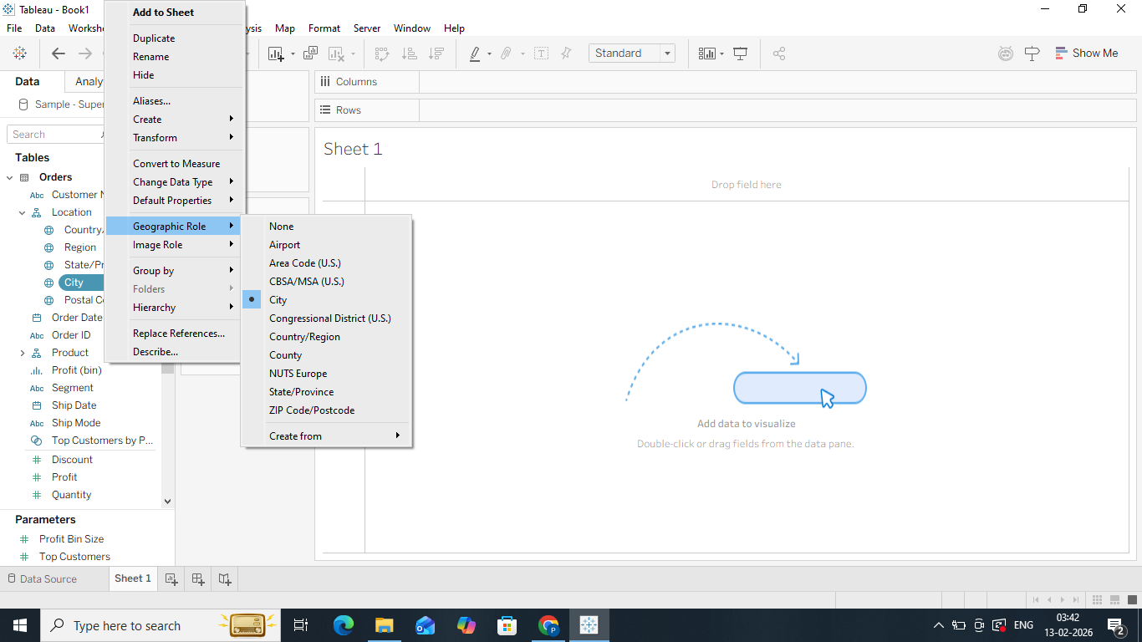
- Create a basic map
  - Drag the geographic field to the Rows or Columns shelf, or directly to the canvas.

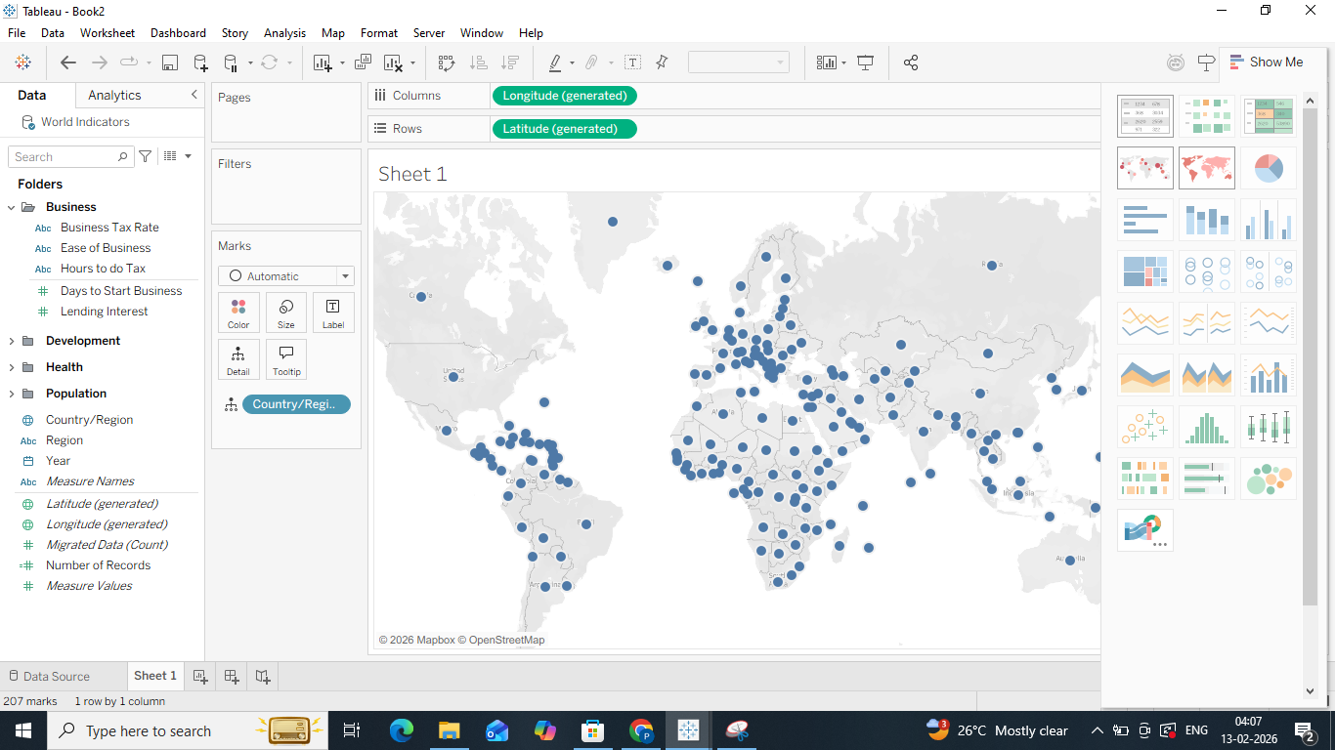
  - Tableau automatically generates a map view.
- Plot measurement data
  - Drag the relevant measure (e.g., water quality parameter, sales value, population) to Color or Size on the Marks card.
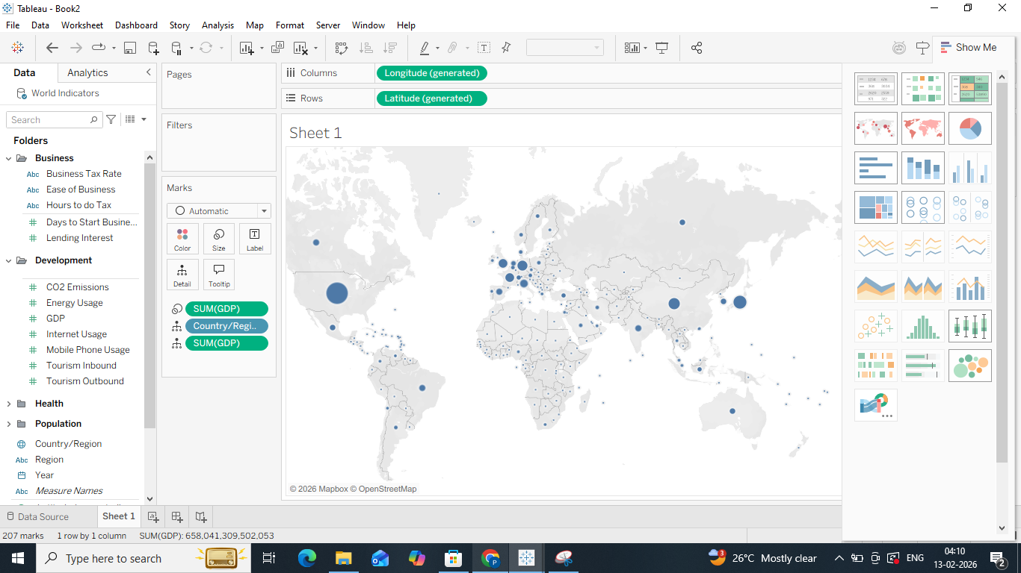
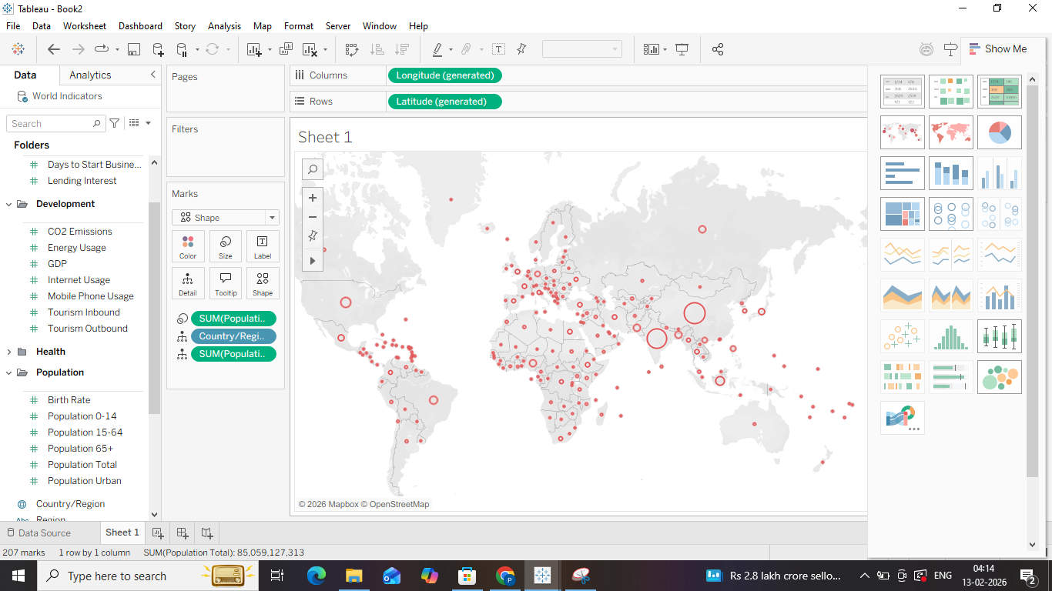
- Adjust visualization settings
  - Use the Marks card to change mark type (circle, filled map).
  - Adjust color gradients and size for better visibility.

Observation
- Identify spatial distribution patterns such as clustering, or regional dominance.
- Observe variations in values across locations and detect any outliers or anomalies.
- Note initial trends such as high or low concentration zones.
TASK 2: Observation After Plotting Various Forms of Maps (Based on Visualization Choices)
Steps in Tableau
- Switch between map types
  - From the Marks card, change the mark type to:
    - Symbol Map for point-based data
    - Filled Map for area-based comparison
    - Density Map to identify hotspots
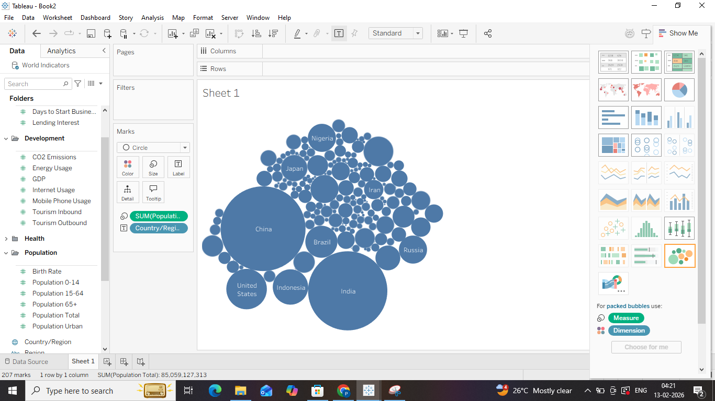
- Apply multiple measures
  - Drag additional measures to Color, Size, or Label to represent different attributes.
  - Use Measure Names and Measure Values to compare multiple parameters.
- Use layers and map details
  - Enable map layers such as borders, streets, and landmarks from Map → Map Layers.
  - Overlay different datasets if available using spatial joins or blending.
- Apply filters
  - Add filters based on time, category, or threshold values to refine the map.
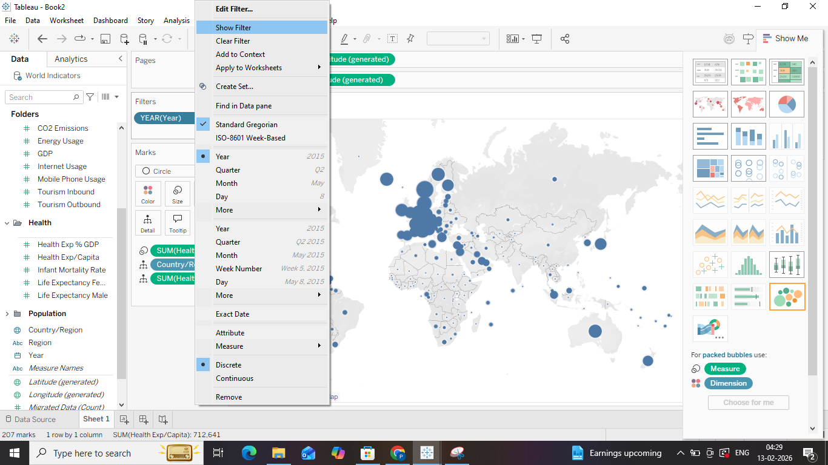

  - Use interactive filters to dynamically update the visualization.
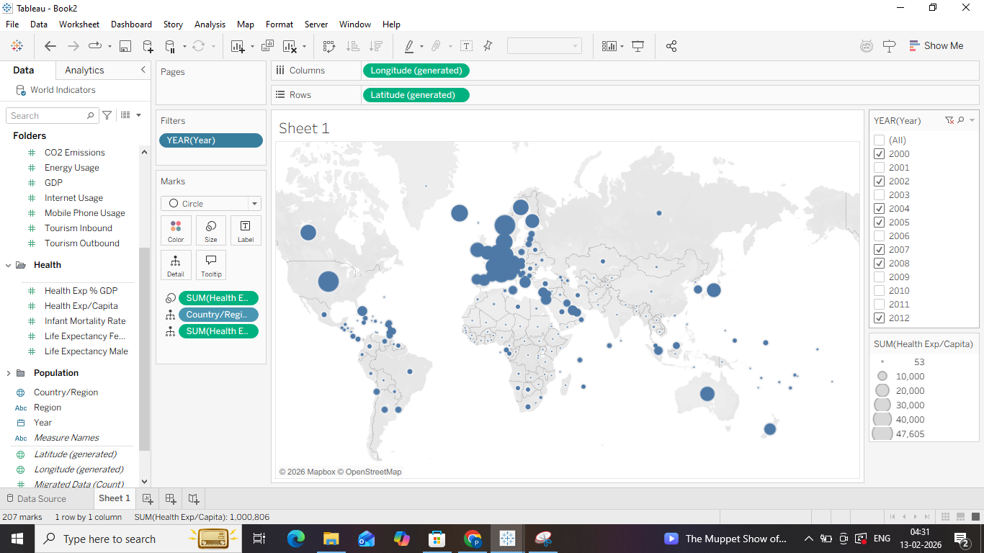
- Customize tooltips
  - Edit tooltips to display contextual information when hovering over regions or points.
Observation
- Compare how different visualization types emphasize different spatial characteristics.
- Identify hotspots, gradients, and regional contrasts more clearly.
- Observe how filtering and layering reveal hidden spatial relationships.

TASK 3: Interpretation of the Visualized Map

Steps in Tableau
- Analyze spatial patterns
  - Examine color intensity, symbol size, and density to understand magnitude and variation.
  - Identify consistent high-value or low-value regions.
- Compare across regions
  - Use legends and scale bars to interpret relative differences.
  - Analyze regional disparities and spatial correlations.
- Use interactivity for deeper insight
  - Hover over points or regions to read detailed tooltips.
  - Use filters and parameters to analyze changes across time or categories.
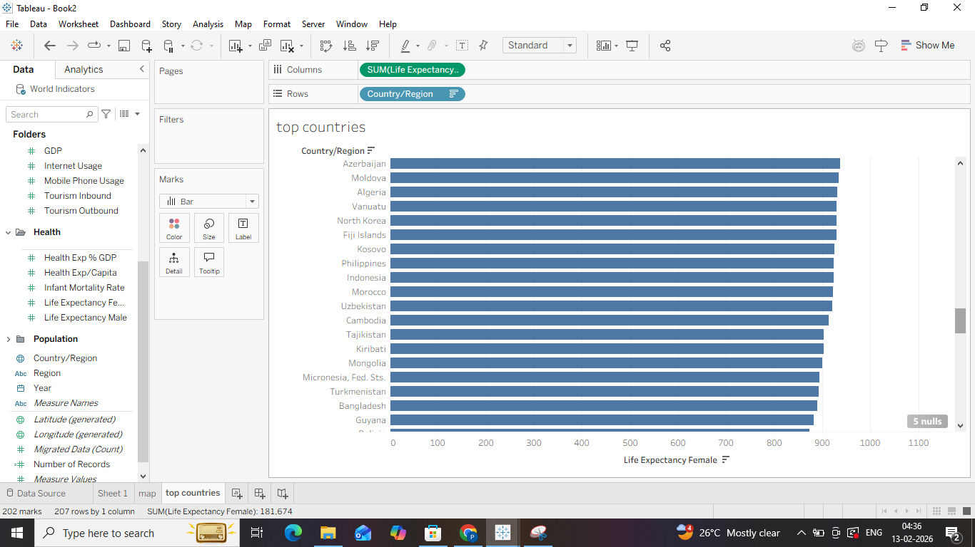
- Create dashboards
  - Combine maps with charts, tables, or KPIs in a dashboard.
  - Enable actions such as highlight, filter, or drill-down for interactive analysis.
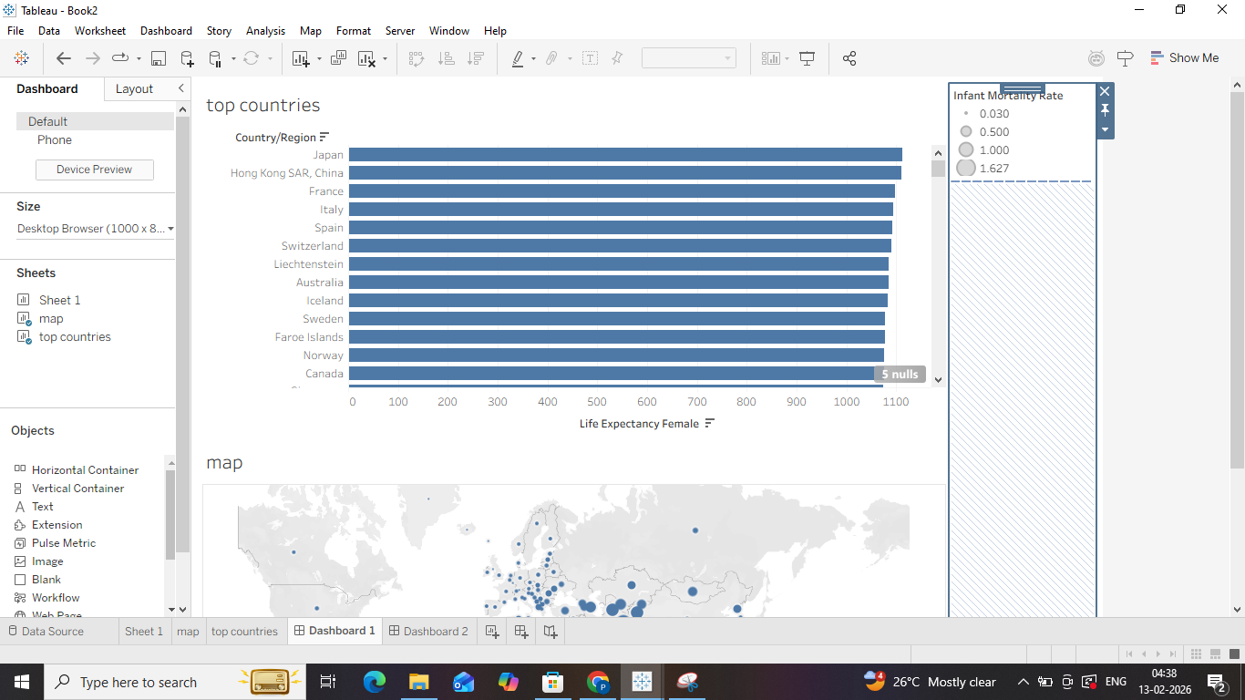
- Draw conclusions
  - Relate observed spatial trends to real-world factors such as geography, infrastructure, population, or environmental conditions.
  - Document insights that support decision-making or further analysis.

Interpretation
- Translate visual patterns into meaningful insights.
- Explain why certain regions show higher or lower values.
- Support conclusions using visual evidence from the map

Sample task to be observed in the Laboratory

Search/locate and download the geospatial Data (Use same dataset if it contains location information)

To learn how to visualize geospatial data

Auto Geo-tagging

Custom Geo-tagging

Apply heat map

Try various forms of heat maps

Analyse the visualization and write your interpretation after observation on heat-map

Interactive filtering over map

Following maps should be demonstrated

Proportional symbol maps

Choropleth maps (filled maps)

Point distribution maps

Density maps (heatmaps)

Flow maps (path maps)

Spider maps (origin-destination maps)
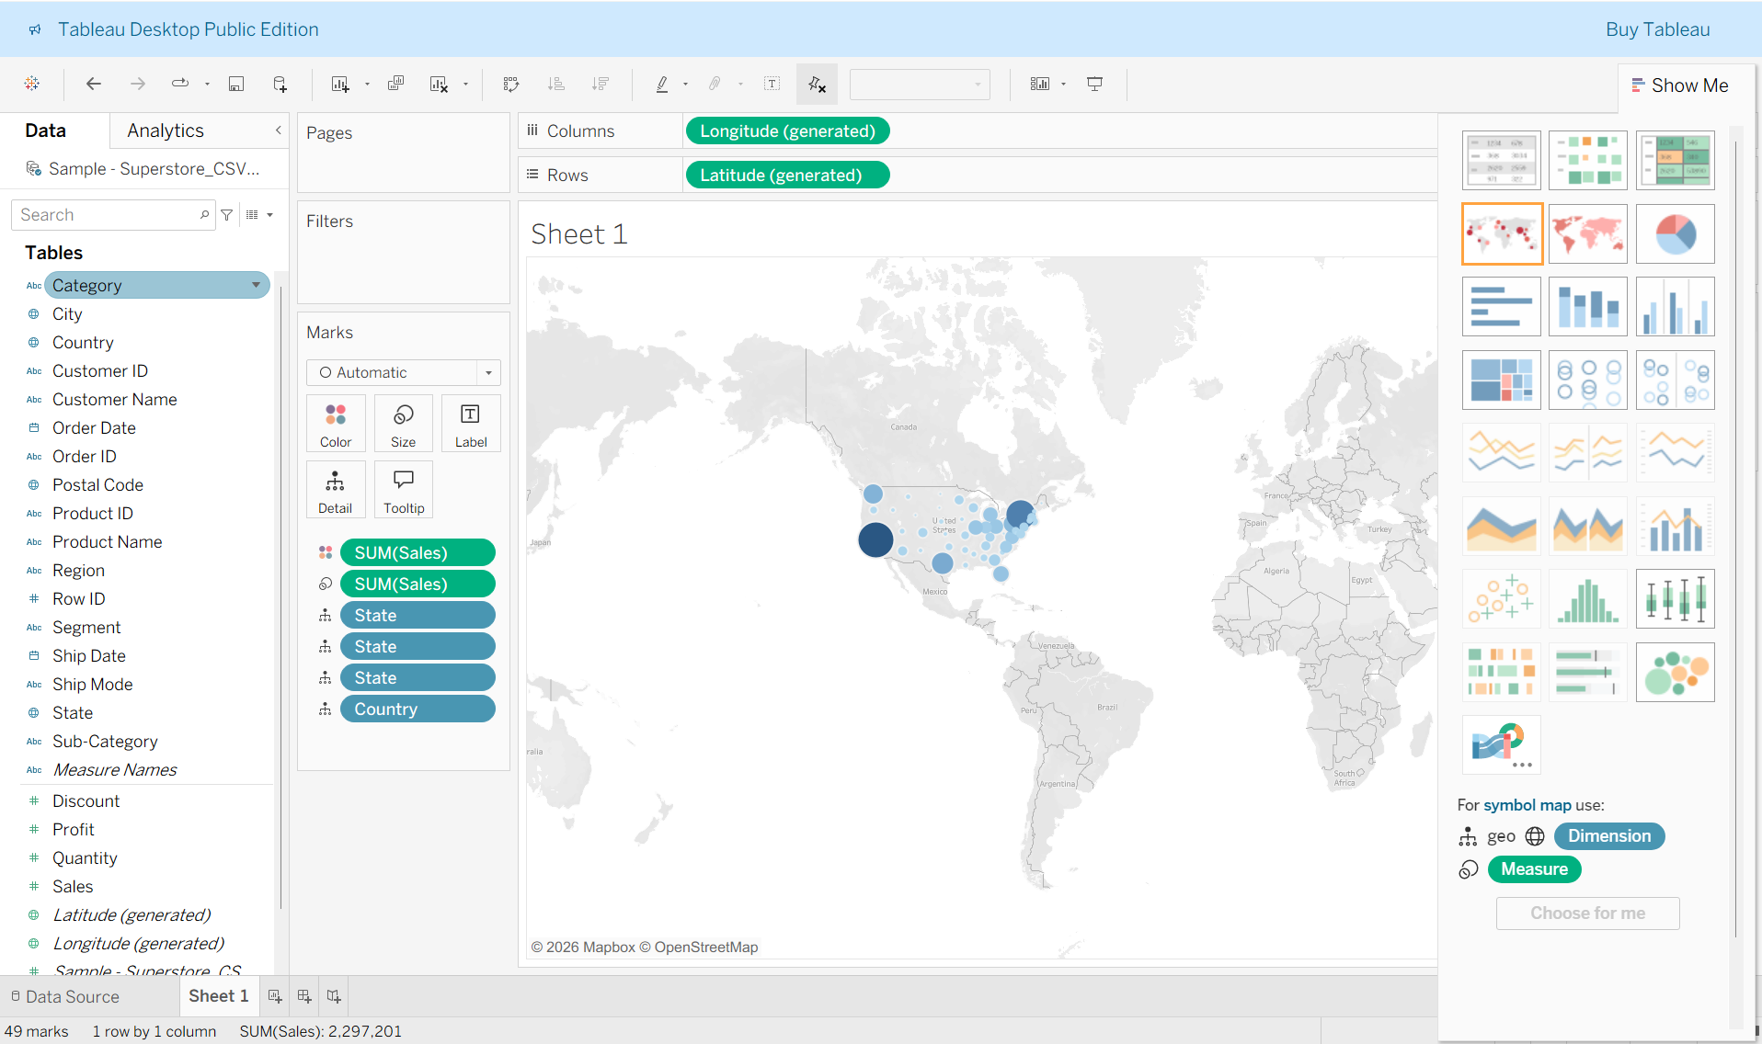
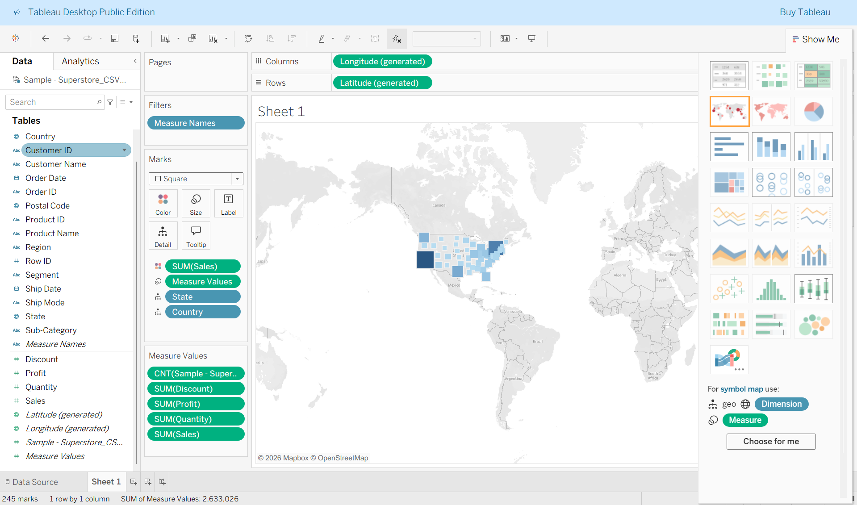

Proportional symbol map
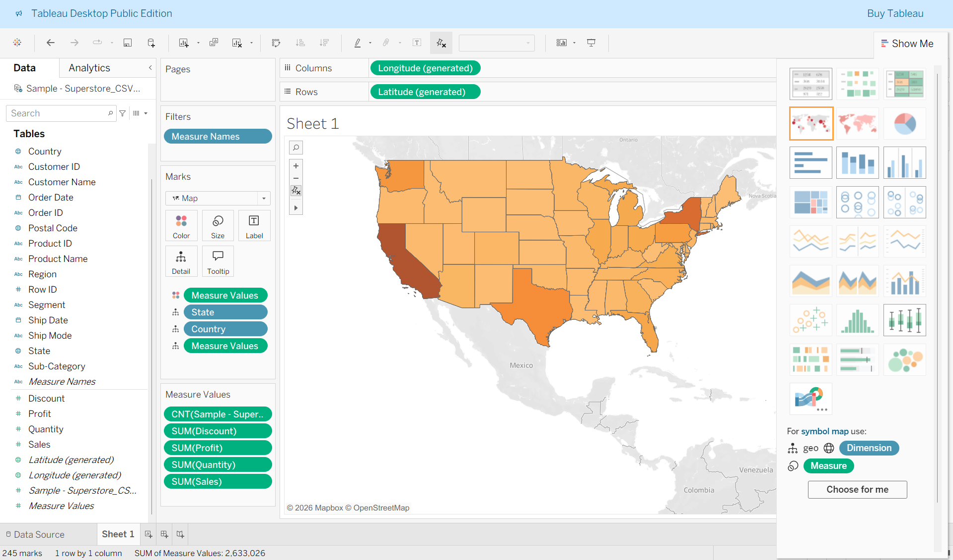
Choropleth maps (filled maps)
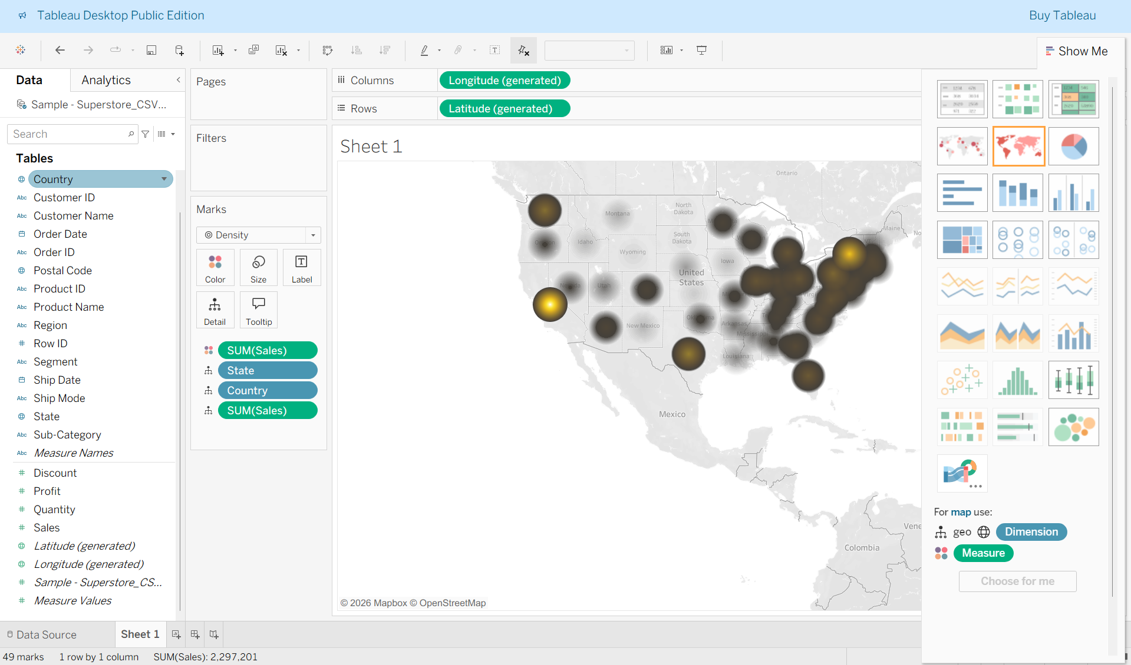

Point distribution maps
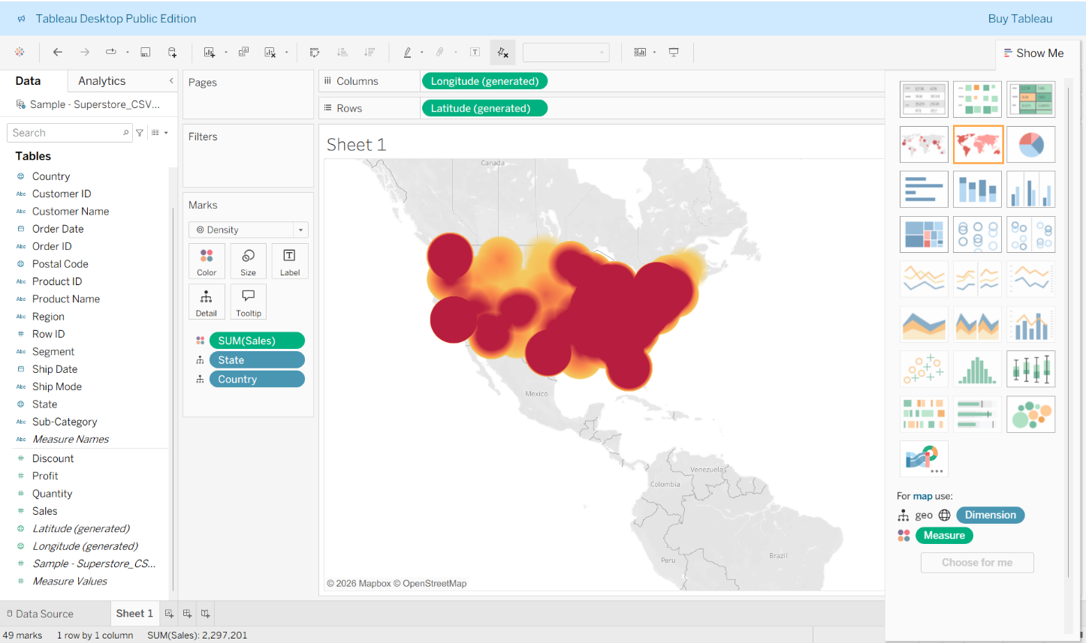
Density Maps (Heat maps)
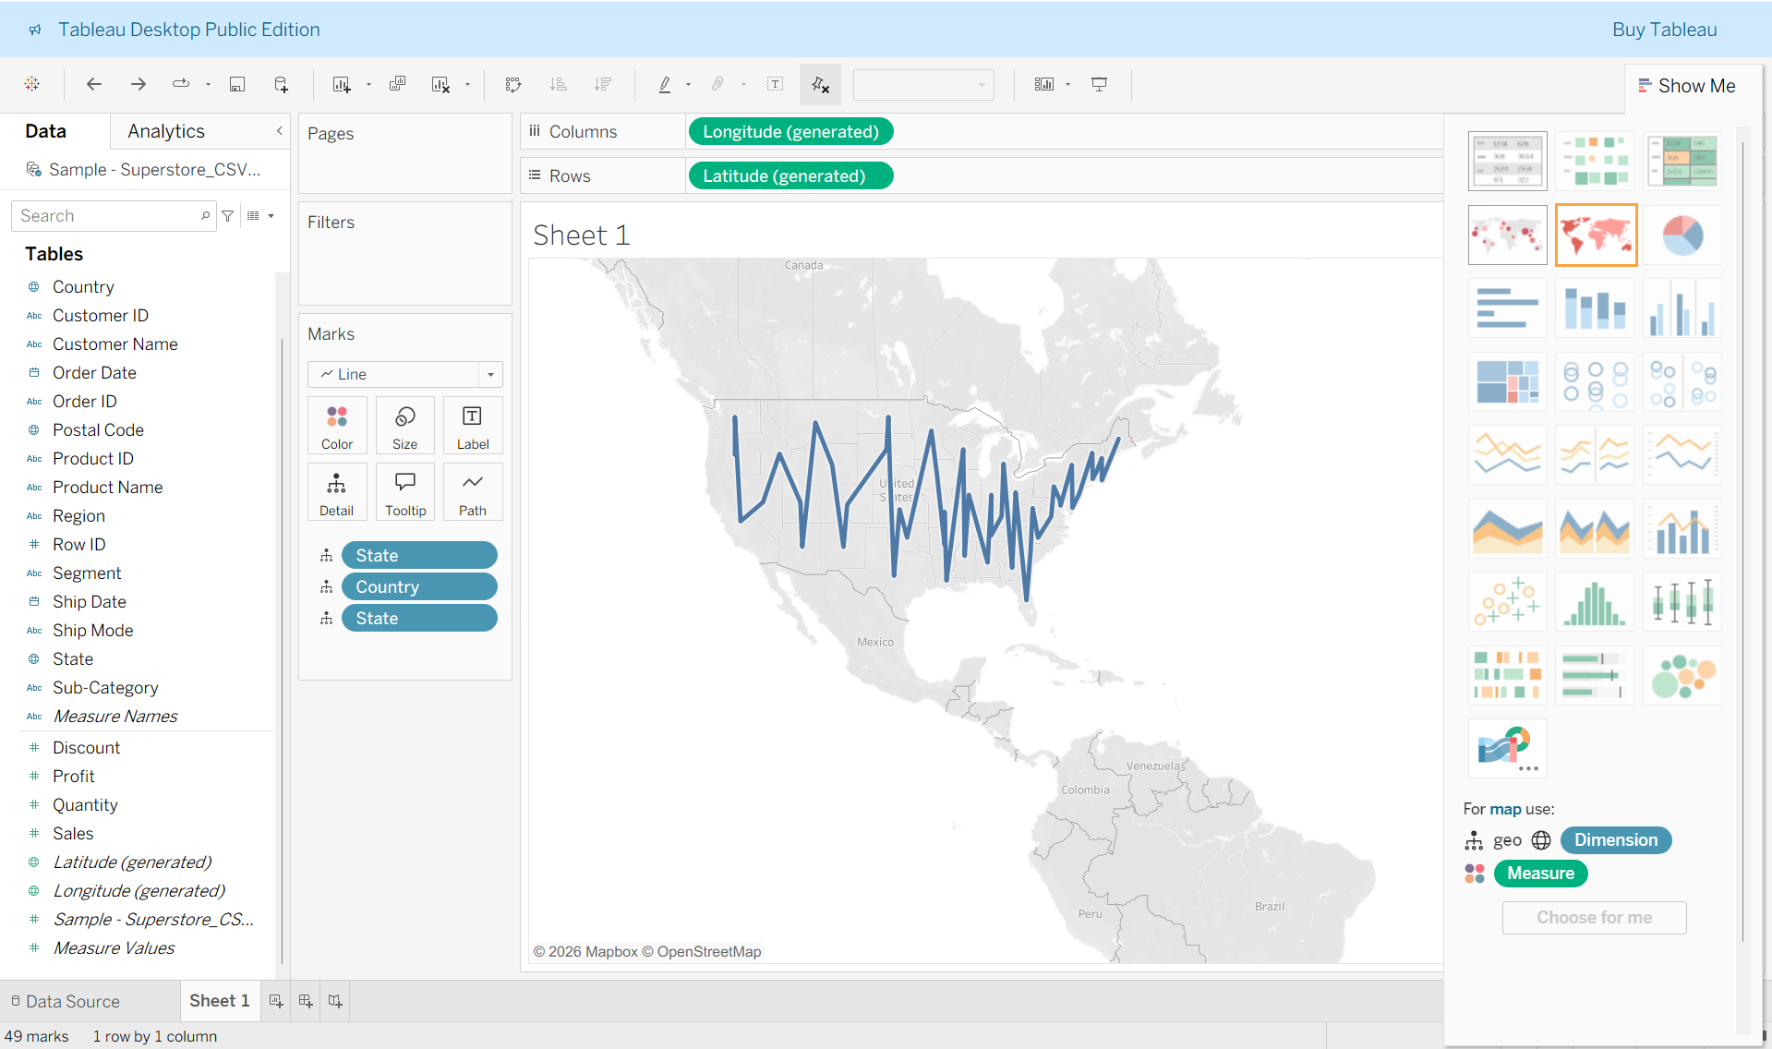
Flow maps (path maps)
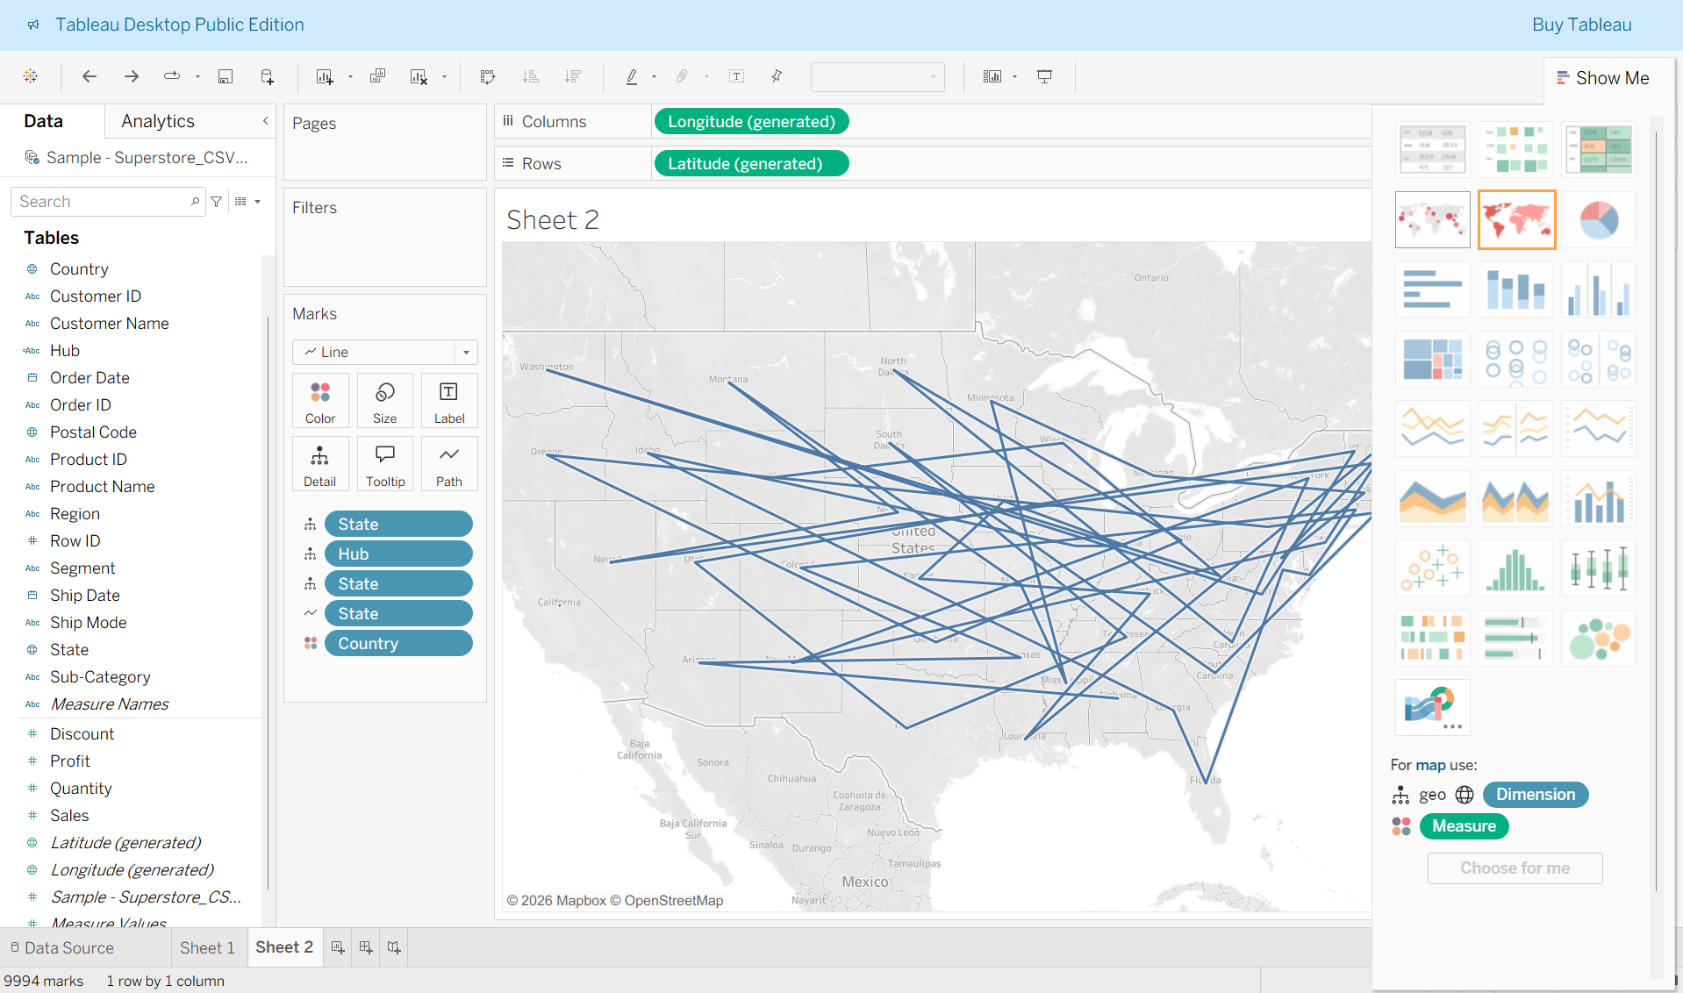
Spider maps
Post Laboratory Questions:
Following questions are to be handwritten and attach the photograph of the answer in this document.
1. Explain the Choropleth maps
A Choropleth map is a thematic map where areas such as states or countries are shaded with different colors based on the value of a variable. Darker colors usually represent higher values, while lighter colors represent lower values. It is used to compare data across geographic regions. In Tableau, a choropleth map is created using the Filled Map option and placing a measure on the Color shelf. It helps in identifying regional variations, trends, and spatial disparities easily.
Conclusion
In this experiment, geospatial data was visualized using Tableau to understand spatial distribution and regional patterns. Different map types such as proportional symbol maps, choropleth maps, point distribution maps, and density maps were used to analyze location-based data effectively. The activity demonstrated how geographic information can be transformed into meaningful visual insights through mapping techniques, filtering, and interactive features. Overall, the experiment improved understanding of geospatial visualization and its role in data-driven analysis.

